ENROLMENT QUESTIONNAIRE

NAME : __________________________
SCHOOL : __________________________
YEAR : __________________________
COURSE : __________________________
CONTACT NUMBER : __________________________
EMAIL : __________________________

INSTRUCTIONS TO TAKE NOTE
- You are required to complete ALL three sections.
- You are to draw in the space provided for you on each of the pages.
- DO NOT copy the examples as your answer.

Section 1
Draw 10 (TEN) objects/items you can see in a LIVING ROOM on the next page.
You can draw the same object in different angle/view.

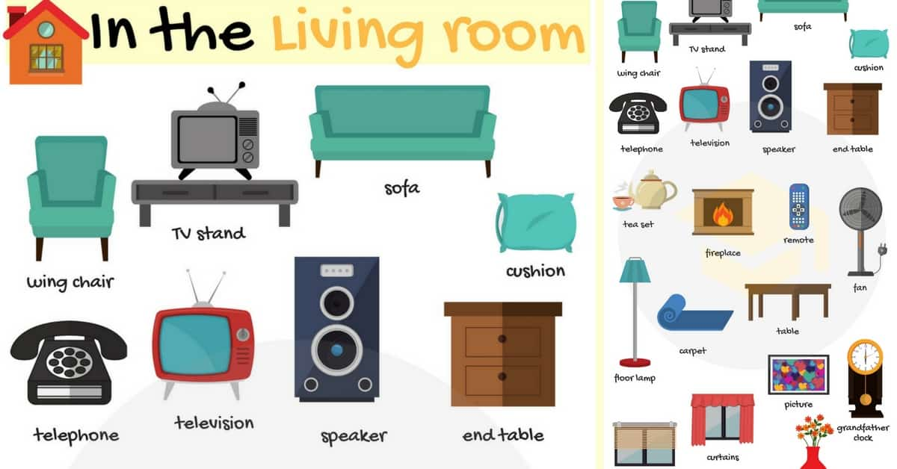

Section 2
Draw a KITCHEN background.
You are to draw your background in one-point or two-point perspective.

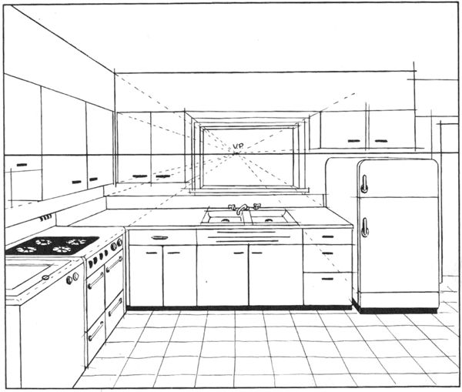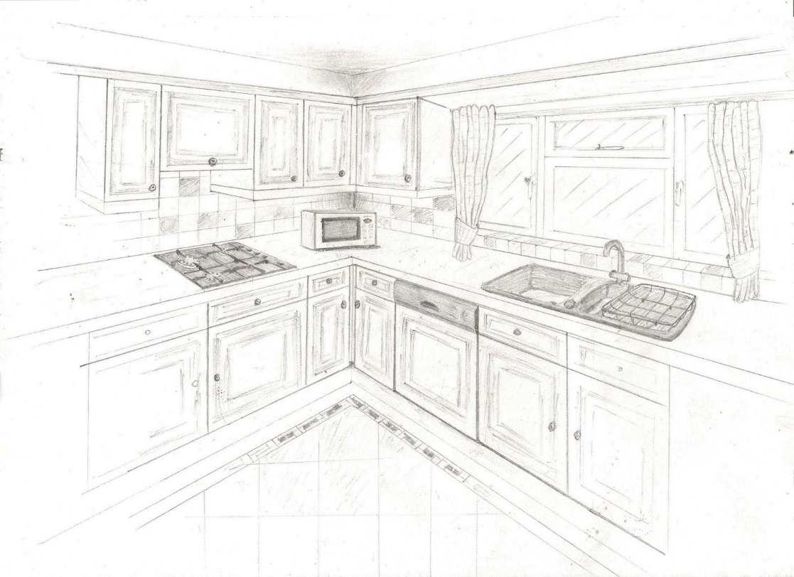

Section 3
Draw 3 to 5 characters concept art. Include both male and female characters. Each A4 should have 2 characters.
You are to include:
- Head + upper torso view
- Full body view
Or
- Full body front facing view
- At least 2 unique poses
