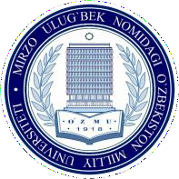
To the Rector of the National Institute
of Fine Arts and Design named after
Kamoliddin Bekhzod
N.B.Sayfullaev

APPLICATION FORM

from

(full name of enrollee)

Please allow me to participate in an interview for admission to the form of studying in the direction of education (undergraduate):

(full-time, extramural)
in
(code and title of the direction of education)
language.

(russian, uzbek)

Gender: male female
Education secondary secondary specialized higher Graduated from

(name of educational institution)
in year in .
(name of direction)

Certificate of education (certificate or diploma): series and number №

I know languages.
(foreign language name and level)

The interview will be held in language.
(russian, uzbek)

Date and place of my birth: year
(year)

(day)
,
(month)

(place of birth)

Permanent address:

(permanent address is indicated by passport (republic, region

city, district, street, number of house and flat)

Passport data: ,

(series) (number) (issued date and authority)

Work experience (if any)

Information about parents:
(last place of work, position, period of work)

Father
(full name, date of birth, place of work, telephone number)

Mother
(full name, date of birth, place of work, telephone number)

Information about participation in international and republican Olympiads, contests and
sports competitions (if participated)

(discipline (specialty) of the competition, date and place taken)

If you have any health problems, please enter the information below:

(full name of enrollee) (sign) (filing date)

